Sri Lanka Institute of Information
Technology



BSc (Hons) in Information Technology Specializing in Data Science

IT3021 – Data Warehousing and Business Intelligence

Year 3 Semester 1-2026
Assignment 2
IT23858398
DILRANGA M.M.P.M
Table of Contents
1 Step 1: Data Source 4
1.1 Introduction 4
1.2 Description of the Data Warehouse 4
1.3 Fact Table Description 5
1.3.1 Main attributes in FactAccident: 5
1.3.2 Purpose of the fact table 5
1.4 Dimension Table Descriptions 5
1.4.1 DimDate 5
1.4.2 DimLocation 6
1.4.3 DimRoadCondition 7
1.4.4 DimCasualty 7
1.5 Relationships in the Data Warehouse 8
1.6 Why the Data Warehouse is Suitable ? 8
2 SSAS Cube Implementation 11
2.1 Introduction 11
2.2 Creation of SSAS Project 11
2.3 Data Source Configuration 12
2.4 Data Source View (DSV) 13
2.5 Cube Creation 14
2.6 Measure Configuration 15
2.7 Hierarchy Implementation 15
2.8 Cube Deployment and Processing 16
2.9 Cube Browsing and Validation 16
3 Demonstration of OLAP Operations in Excel 17
3.1 ROLL-UP 17
3.2 DRILL-DOWN 18
3.3 SLICE 19
3.4 DICE 19
3.5 PIVOT 20
4 STEP 4 - POWER BI REPORTS (DOCUMENTATION) 21
4.1 Power BI Reports 21
4.1.1 Introduction 21
4.2 Data Preparation and Modeling 21
4.2.1 DAX Measures Created: 21
4.3 Report 1 - Matrix Report 23
4.3.1 Configuration: 23
4.4 Report 2 - Cascading Slicers and Multiple Visuals 24
4.4.1 Slicers: 24
4.4.2 Visuals Included: 24
4.5 Report 3 - Drill-Down Report 25
4.5.1 Configuration: 25
4.6 Report 4 - Drill-Through Report 26
4.6.1 Implementation: 26
4.7 Publishing to Power BI Service 27
4.8 Summary 27

Figures
1. Figure 1: Star schema of UKRoadAccident_DW used as the data source for Assignment 2 9
2. Figure 1: UKRoadAccident_DW Database and Tables in SQL Server Management Studio 10
3. Figure 3: SSAS Project Structure 11
4. Figure 4: Data Source Configuration 12
5. Figure 5: Data Source View with Fact and Dimension Tables 13
6. Figure 6: Cube Structure with Measures and Dimensions 14
7. Figure 7: Date Hierarchy in DimDate 15
8. Figure 8: Cube Browser Showing Analytical Results 16
9. Figure 9: Roll-up Operation in Excel 17
10. Figure 10: Drill-down Operation in Excel 18
11. Figure 11: Slice Operation in Excel 19
12. Figure 12: Dice Operation in Excel 19
13. Figure 13: Pivot Operation in Excel 20
14. Figure 14: Power BI Data Model with Relationships 22
15. Figure 15: Matrix Report Showing Grouped Accident Data 23
16. Figure 16: Report with Cascading Slicers and Multiple Visuals 24
17. Figure 17: Drilldown Report Using Date Hierarchy 25
18. Figure 18: Drill through Report Navigation 26
19. Figure 19: Power BI Reports Published in Power BI Service 27

Step 1: Data Source

Introduction
The data source used for Assignment 2 is the data warehouse that was designed and implemented in Assignment 1. The warehouse was developed in SQL Server and named UKRoadAccident_DW. It stores integrated, cleaned, and transformed data related to UK road accident records for the year 2009.
Unlike the original source dataset used in Assignment 1, which existed in multiple formats such as CSV, Excel, and SQL tables, the data warehouse provides a centralized and structured analytical repository. This makes it suitable for multidimensional analysis, SSAS cube implementation, Excel-based OLAP operations, and Power BI reporting.
The purpose of using the data warehouse as the source for Assignment 2 is to support analytical processing rather than transactional processing. Since the data has already been transformed into a dimensional model, it is better suited for summarization, aggregation, drill-down analysis, and interactive reporting.

Description of the Data Warehouse
The data warehouse was modeled using a star schema. It contains one central fact table and several surrounding dimension tables. The fact table stores measurable accident-related values, while the dimension tables store descriptive context used for analysis.
The warehouse consists of the following tables:
- FactAccident
- DimDate
- DimLocation
- DimRoadCondition
- DimCasualty
This structure supports efficient analytical queries because the fact table can be aggregated across multiple business perspectives such as time, location, road condition, and casualty details.

Fact Table Description
The central table in the warehouse is FactAccident. This table stores the measurable and transactional values related to each accident record.

Main attributes in FactAccident:
- AccidentFactKey
- AccidentTxnID
- ReferenceNumber
- DateKey
- LocationKey
- RoadConditionKey
- CasualtyKey
- NumberOfVehicles
- TimeKeyHHMM
- SeverityScore
- accm_txn_create_time
- accm_txn_complete_time
- txn_process_time_hours

Purpose of the fact table
The fact table is used to store the core analytical values of the accident process. It supports numerical analysis such as:
- counting accidents
- summing vehicle involvement
- analyzing severity
- measuring process duration
Each record in the fact table represents one accident transaction at the chosen grain of the warehouse.

Dimension Table Descriptions

DimDate
The DimDate table stores date-related descriptive information. It enables time-based analysis at different levels such as year, quarter, month, and day.
Main attributes:
- DateKey
- FullDate
- DayNumberOfMonth
- MonthNumber
- MonthName
- QuarterNumber
- YearNumber
Analytical use:
This dimension is useful for:
- yearly accident analysis
- monthly accident trends
- quarter-based comparisons
- drill-down from year to month to date

DimLocation
The DimLocation table stores the geographical and road classification details of accidents.
Main attributes:
- LocationKey
- Easting
- Northing
- FirstRoadClass
Analytical use:
This dimension supports:
- accident analysis by location
- grouping accidents by road classification
- identifying spatial patterns in accidents

DimRoadCondition
The DimRoadCondition table stores descriptive information about road and environmental conditions present during accidents.

Main attributes:
- RoadConditionKey
- RoadSurface
- LightingConditions
- WeatherConditions
- StartDate
- EndDate
- IsCurrent

Analytical use:
This dimension allows users to analyze:
- accidents under different weather conditions
- the effect of lighting conditions
- the effect of road surface conditions
It was also designed with Slowly Changing Dimension-related fields, allowing support for historical tracking if required.

DimCasualty
The DimCasualty table stores descriptive casualty and vehicle-related information.

Main attributes:
- CasualtyKey
- CasualtyClass
- CasualtySeverity
- SexOfCasualty
- AgeBand
- TypeOfVehicle

Analytical use:
This dimension is used to analyze:
- severity of casualties
- accident trends by age groups
- differences by gender
- distribution of accidents across vehicle types
The AgeBand attribute was derived during ETL to improve analysis and reporting.

Relationships in the Data Warehouse
The fact table is linked to the dimension tables using surrogate foreign keys. These relationships form the star schema.
The relationships are as follows:
- FactAccident.DateKey → DimDate.DateKey
- FactAccident.LocationKey → DimLocation.LocationKey
- FactAccident.RoadConditionKey → DimRoadCondition.RoadConditionKey
- FactAccident.CasualtyKey → DimCasualty.CasualtyKey
These relationships allow the fact data to be analyzed from multiple perspectives.

Why the Data Warehouse is Suitable ?
The data warehouse is suitable as the source for Assignment 2 because it has already been transformed into an analytical structure. This means it is ready for:
- SSAS cube creation
- hierarchy definition
- OLAP operations in Excel
- interactive reporting in Power BI
Compared to the original source files, the warehouse is easier to use because:
- data types are standardized
- duplicate handling is completed
- surrogate keys are already resolved
- measures and dimensions are clearly separated
Therefore, the warehouse provides a reliable and efficient source for multidimensional analysis and business intelligence reporting
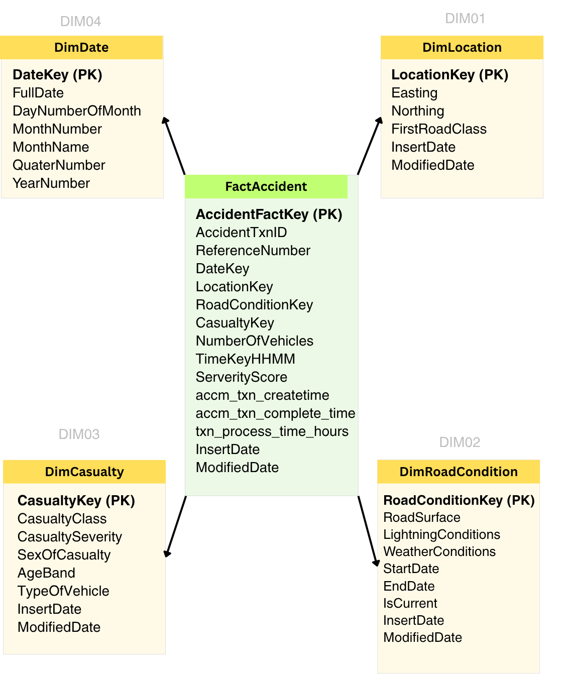

Figure 1: Star schema of UKRoadAccident_DW used as the data source for Assignment 2
The figure illustrates the data warehouse used as the source for Assignment 2. The central fact table is connected to four dimension tables, enabling multidimensional analysis using SSAS, Excel, and Power BI.

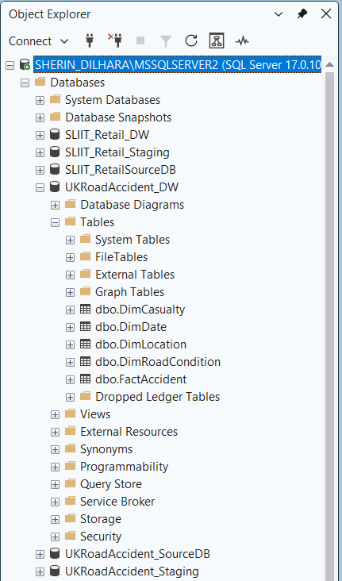

Figure 1: UKRoadAccident_DW Database and Tables in SQL Server Management Studio
This figure shows the UKRoadAccident_DW database as viewed in SQL Server Management Studio (SSMS). The Object Explorer displays the structure of the data warehouse, including the central fact table (FactAccident) and the associated dimension tables (DimDate, DimLocation, DimRoadCondition, and DimCasualty). This confirms that the data warehouse has been successfully created and contains all required tables for analytical processing.

SSAS Cube Implementation

Introduction
In this step, a multidimensional OLAP cube was developed using SQL Server Analysis Services (SSAS). The cube was created based on the data warehouse developed in Assignment 1 (UKRoadAccident_DW). The purpose of the cube is to enable efficient multidimensional analysis of accident data using measures and dimensions.
The cube allows users to perform aggregation, drill down, slicing, and dicing operations, which are essential for business intelligence and analytical reporting.

Creation of SSAS Project
A new Analysis Services Multidimensional and Data Mining Project was created using Visual Studio (SSDT). This project serves as the environment for building and deploying the OLAP cube.
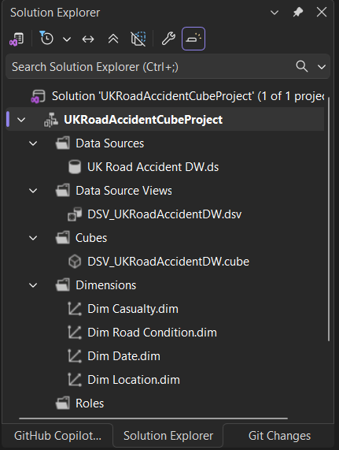

Figure 3: SSAS Project Structure
This figure shows the created SSAS project in Visual Studio, including key components such as Data Sources, Data Source Views, Cubes, and Dimensions.

Data Source Configuration
A data source was created to establish a connection between SSAS and the SQL Server data warehouse (UKRoadAccident_DW). The connection was configured using the current user credentials to ensure proper access to the database.
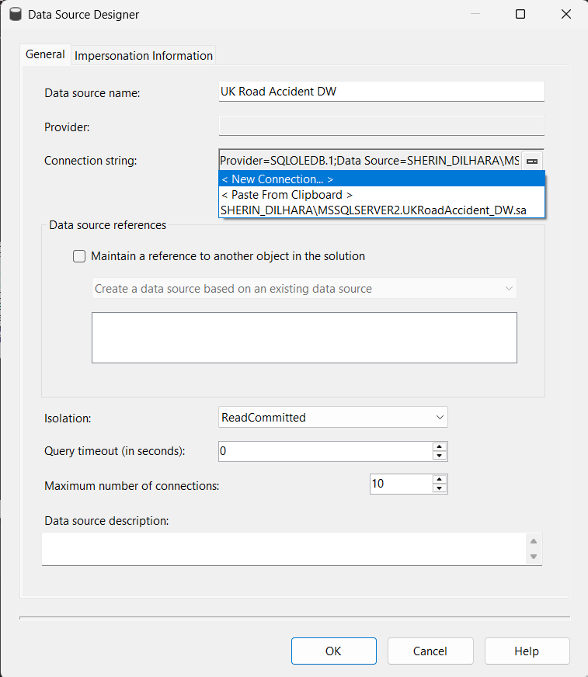

Figure 4: Data Source Configuration
This figure shows the data source connection to the UKRoadAccident_DW database, which is used as the source for cube creation.

Data Source View (DSV)
A Data Source View (DSV) was created to define the logical model of the data warehouse within SSAS. The DSV includes the fact table (FactAccident) and all related dimension tables (DimDate, DimLocation, DimRoadCondition, and DimCasualty).
The relationships between the fact and dimension tables were verified in the DSV to ensure correct cube design.
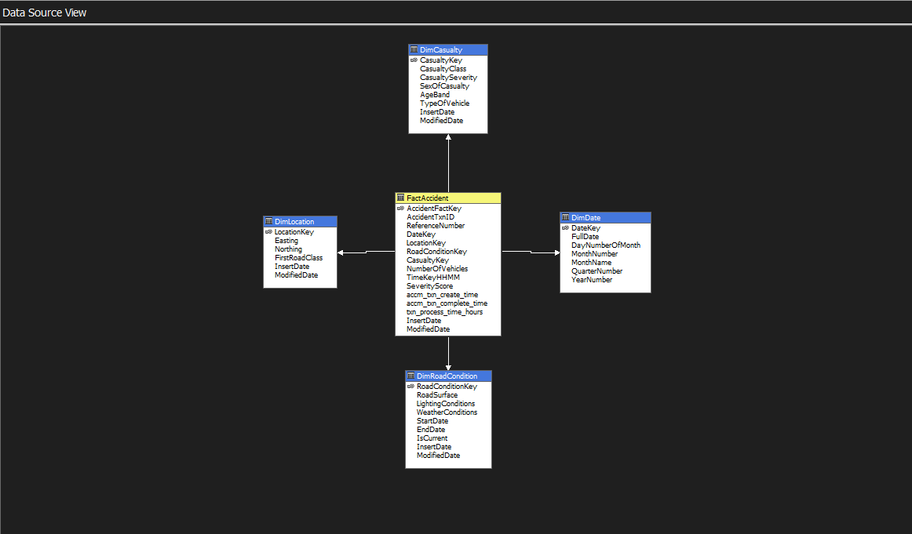

Figure 5: Data Source View with Fact and Dimension Tables
This figure illustrates the Data Source View showing the fact table and its relationships with dimension tables, forming a star schema.

Cube Creation
The cube was created using the Cube Wizard by selecting the FactAccident table as the measure group. Relevant numerical columns were selected as measures, including:
- Number of Vehicles
- Severity Score
- Transaction Process Time Hours
- Accident Count
Dimension tables (DimDate, DimLocation, DimRoadCondition, and DimCasualty) were added to provide analytical perspectives.
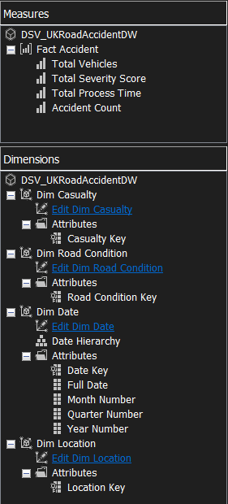

Figure 6: Cube Structure with Measures and Dimensions
This figure shows the cube structure, including the measure group and associated dimensions.

Measure Configuration
The selected measures were renamed to more meaningful names to improve readability and usability in analysis:
- Total Vehicles
- Total Severity Score
- Total Process Time
- Accident Count
These measures allow users to perform aggregation and analysis across multiple dimensions.

Hierarchy Implementation
A hierarchy was created in the DimDate dimension to support drill-down analysis. The hierarchy consists of:
- Year
- Quarter
- Month
- Date
This hierarchy allows users to analyze accident data at different levels of time granularity.
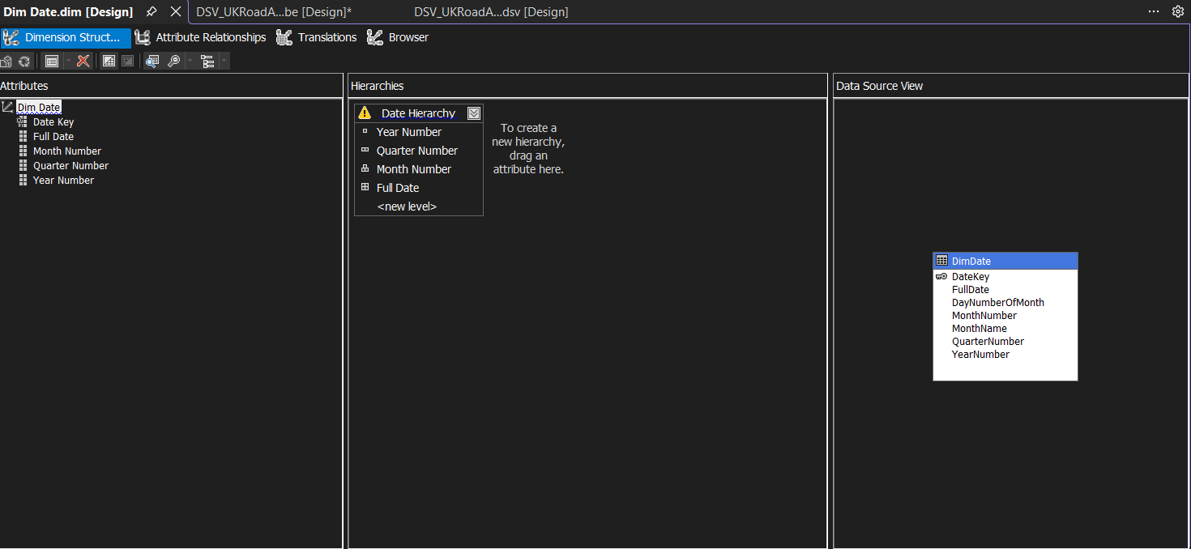

Figure 7: Date Hierarchy in DimDate
This figure shows the hierarchy created in the Date dimension, enabling drill-down from year to date level.

Cube Deployment and Processing
After designing the cube, it was deployed to the SSAS server. The cube was then processed to load data from the data warehouse into the cube structure.
Successful deployment and processing ensured that the cube was ready for querying and analysis.

Cube Browsing and Validation
The cube was tested using the Browser tab in Visual Studio. Measures such as accident count and total vehicles were analyzed using the Date hierarchy to verify that the cube was functioning correctly.
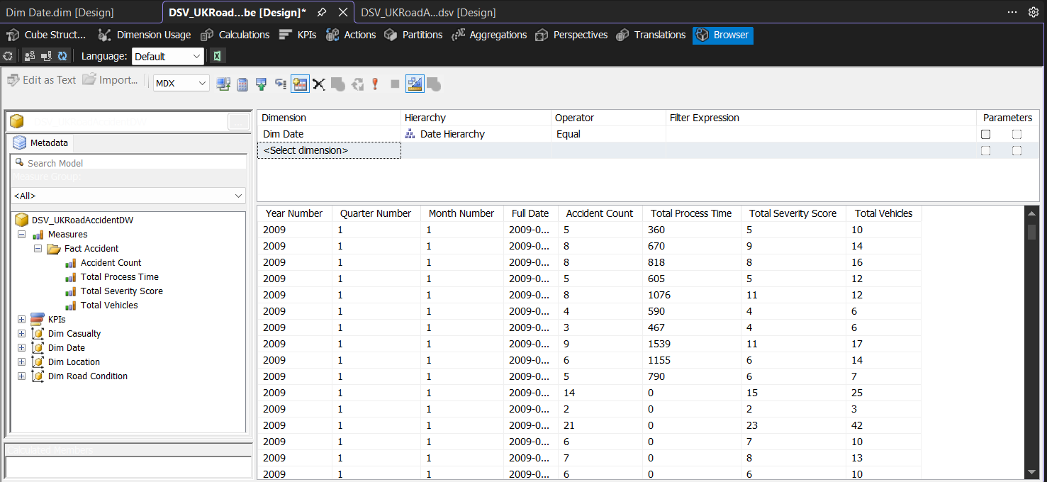

Figure 8: Cube Browser Showing Analytical Results
This figure shows the cube browser with accident data analyzed using dimensions and measures, confirming that the cube has been successfully created and processed.

Demonstration of OLAP Operations in Excel
An Excel workbook was connected to the SSAS cube to perform multidimensional analysis. A PivotTable was created using the cube as the data source. Various OLAP operations were demonstrated to validate the cube’s analytical capabilities.
The following operations were performed:
- Roll-up
- Drill-down
- Slice
- Dice
- Pivot
These operations allow users to analyze data at different levels of detail and from multiple perspectives.

ROLL-UP
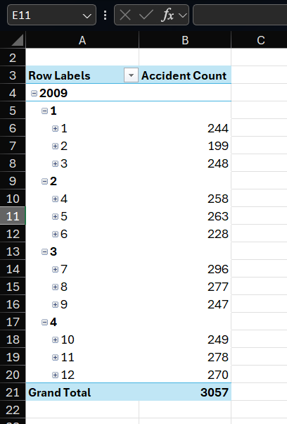

Figure 9: Roll-up Operation in Excel
This figure demonstrates the roll-up operation where detailed monthly data is aggregated to a higher-level yearly summary.

DRILL-DOWN

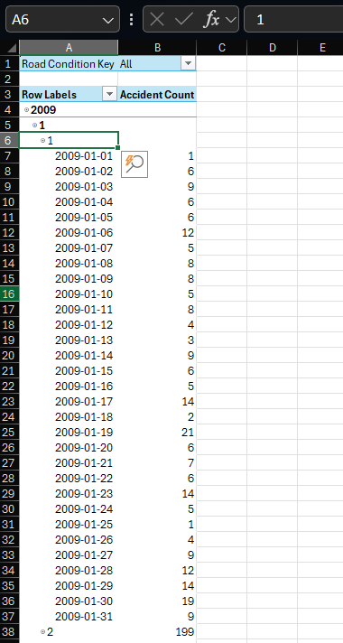

Figure 10: Drill-down Operation in Excel
This figure shows the drill-down operation where data is explored from year level down to quarter, month, and date levels.

SLICE
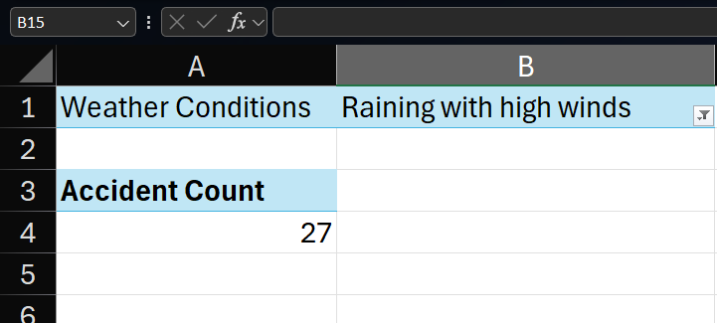

Figure 11: Slice Operation in Excel
This figure demonstrates the slice operation by filtering the dataset based on a single dimension value (weather condition).

DICE
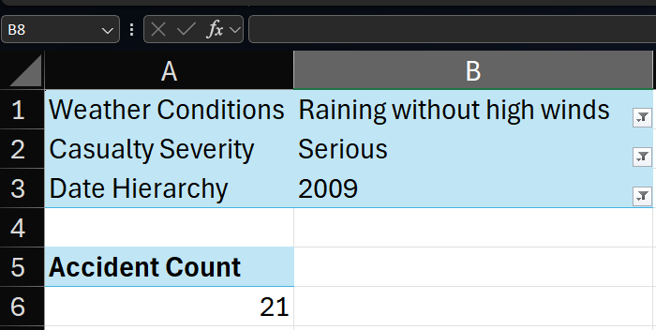

Figure 12: Dice Operation in Excel
This figure demonstrates the dice operation where multiple dimension filters are applied simultaneously to analyze a subset of data.

PIVOT

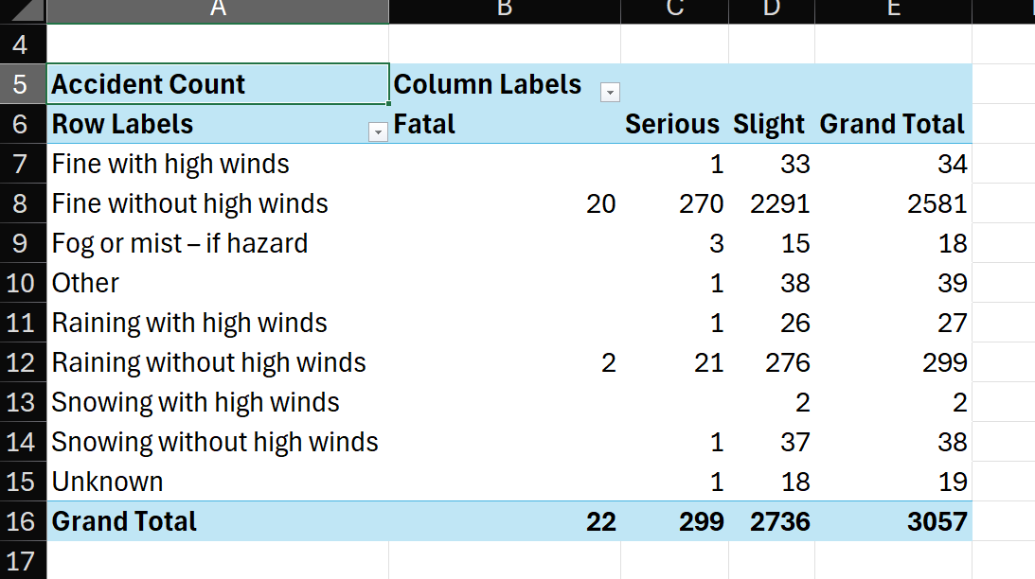
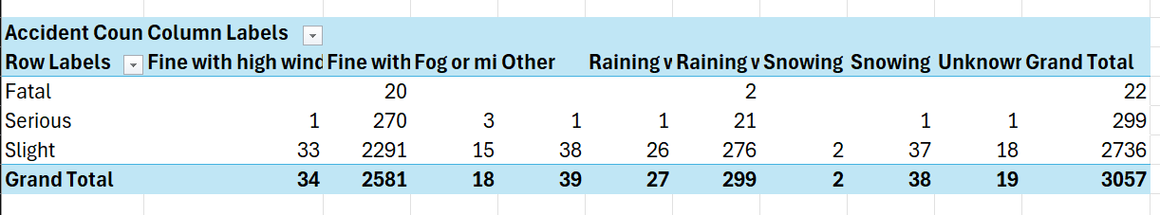

Figure 13: Pivot Operation in Excel
This figure shows the pivot operation where row and column dimensions are interchanged to provide a different analytical perspective.

STEP 4 - POWER BI REPORTS (DOCUMENTATION)

Power BI Reports

Introduction
In this step, Power BI Desktop was used to create interactive reports based on the data warehouse UKRoadAccident_DW. The purpose of these reports is to visualize accident data and provide meaningful insights through charts, slicers, and interactive features.
The data model was built by importing the fact table (FactAccident) and dimension tables (DimDate, DimLocation, DimRoadCondition, and DimCasualty). Relationships between the tables were verified to ensure correct filtering and aggregation behavior.
Several DAX measures were created to support analysis, including accident count, total vehicles, average severity, and average process time.

Data Preparation and Modeling
After connecting Power BI to SQL Server the required tables were loaded into the model. The relationships between the fact table and dimension tables were automatically detected and verified manually.
The star schema structure ensured that filtering from dimension tables correctly affects the fact table.

DAX Measures Created:
- Accident Count = COUNT(FactAccident[AccidentFactKey])
- Total Vehicles = SUM(FactAccident[NumberOfVehicles])
- Average Severity = AVERAGE(FactAccident[SeverityScore])
- Average Process Time = AVERAGE(FactAccident[txn_process_time_hours])
These measures were used across all reports to maintain consistency.
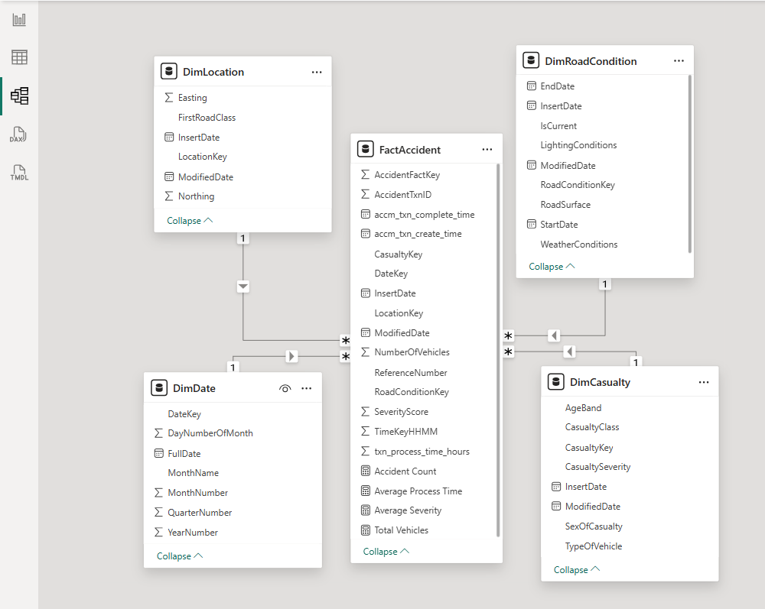

Figure 14: Power BI Data Model with Relationships
This figure shows the Power BI data model, including the fact table and dimension tables with their relationships.

Report 1 - Matrix Report
A Matrix visual was created to display detailed tabular data with row and column groupings. The matrix allows users to view accident data grouped by time and casualty severity.

Configuration:
- Rows: Year, Month
- Columns: Casualty Severity
- Values: Accident Count, Total Vehicles
This report provides a structured tabular view of the data, making it easy to compare values across different categories.
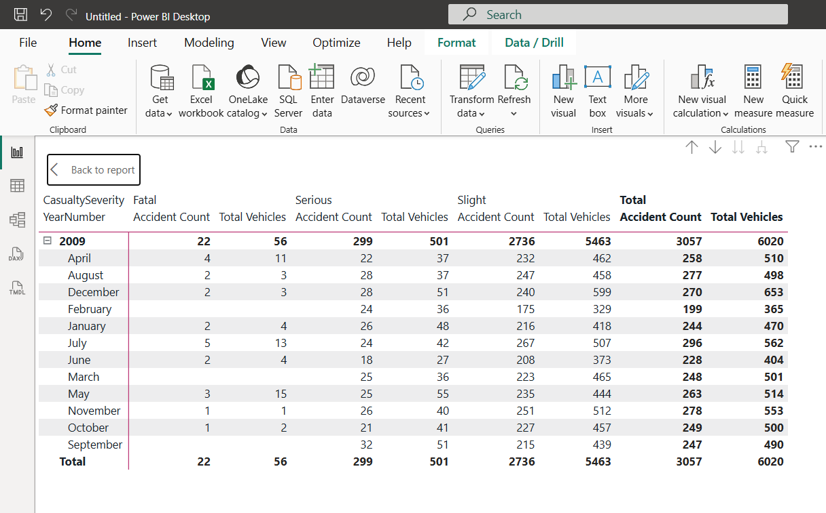

Figure 15: Matrix Report Showing Grouped Accident Data
This figure shows a matrix visual displaying accident counts and total vehicles grouped by time and casualty severity.

Report 2 - Cascading Slicers and Multiple Visuals
A report page was created using multiple slicers and visualizations to provide interactive filtering and insights.

Slicers:
- Weather Conditions
- Lighting Conditions
The slicers were designed to behave as cascading filters, where selecting a value in one slicer dynamically filters the available options in the other slicer.

Visuals Included:
- Bar Chart: Accident Count by Casualty Severity
- Column Chart: Accident Count by Age Band
- Pie Chart: Accident Count by Road Surface
- Card: Total Accident Count
This report allows users to explore accident data interactively based on environmental and casualty-related factors.
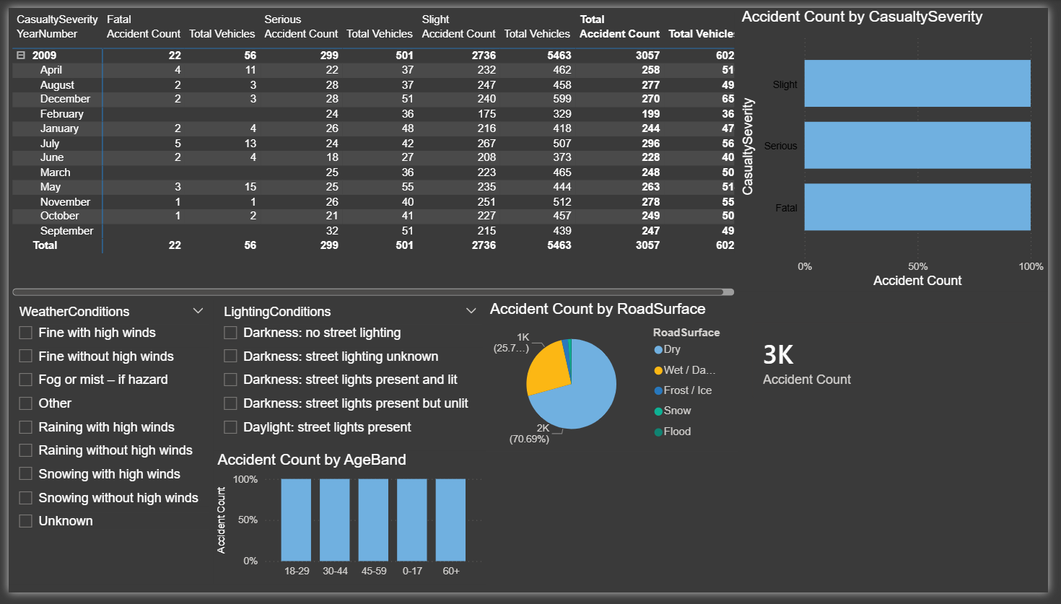

Figure 16: Report with Cascading Slicers and Multiple Visuals
This figure demonstrates a report with multiple slicers and charts. Selecting a value in one slicer dynamically filters the other visuals and slicers.

Report 3 - Drill-Down Report
A drill-down report was created using the Date hierarchy to allow users to explore accident data at multiple levels of detail.

Configuration:
- Axis: Year → Quarter → Month
- Values: Accident Count
Users can drill down from yearly data to quarterly and monthly levels using the drill feature in Power BI.
This report helps identify trends and patterns over time.
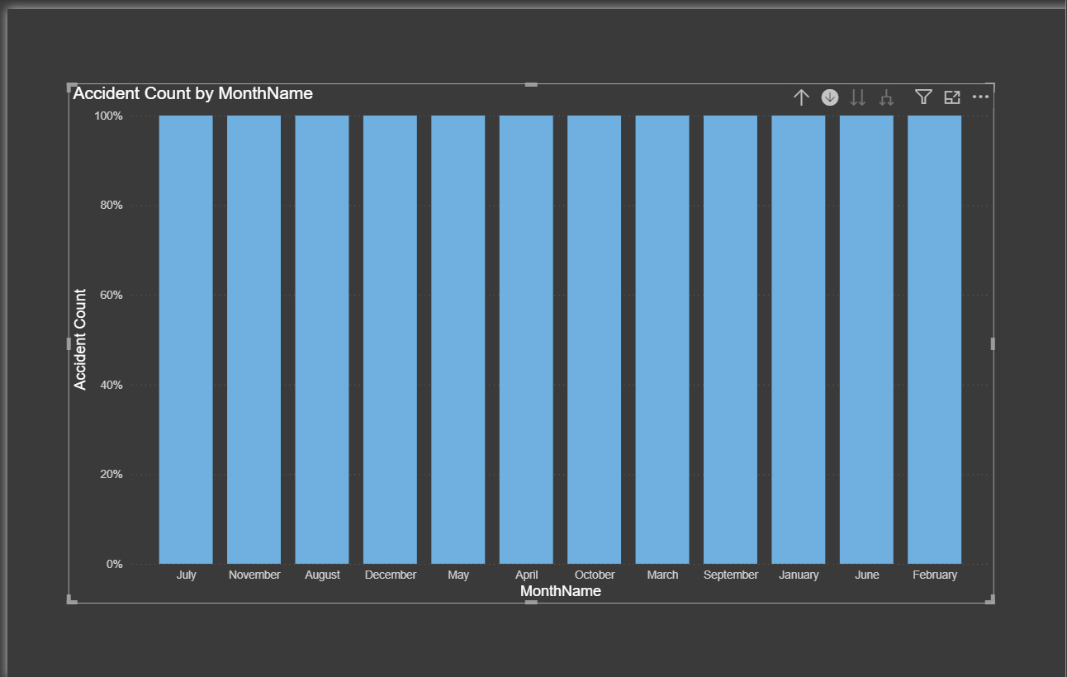

Figure 17: Drilldown Report Using Date Hierarchy
This figure shows a drilldown report where users can navigate from year to quarter and month levels using a hierarchical structure.

Report 4 - Drill-Through Report
A drill-through report was implemented to allow users to navigate from a summary visual to a detailed report page based on selected data.
A dedicated drill-through page was created using Casualty Severity as the drill-through field.

Implementation:
- A drill-through page was created and configured using the field CasualtySeverity
- Detailed visuals such as tables, charts, and cards were added to display filtered data
- On the main report page, users can right-click on a data point (e.g., a specific severity level) and navigate to the drill-through page
This functionality enables users to perform detailed analysis without cluttering the main report.
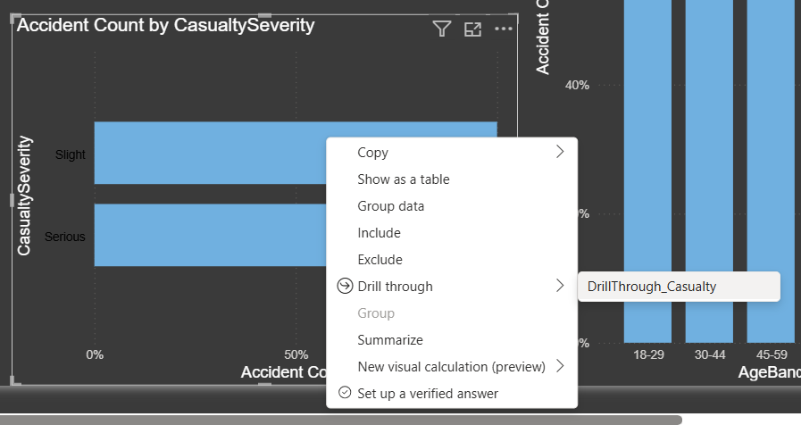

Figure 18: Drill through Report Navigation
This figure demonstrates drill-through functionality where users can right-click on a visual and navigate to a detailed report page filtered based on the selected value.

Publishing to Power BI Service
After creating the reports, the Power BI file was published to Power BI Service. This allows the reports to be accessed online and shared.
Publishing ensures that the reports are available for demonstration as required by the assignment.
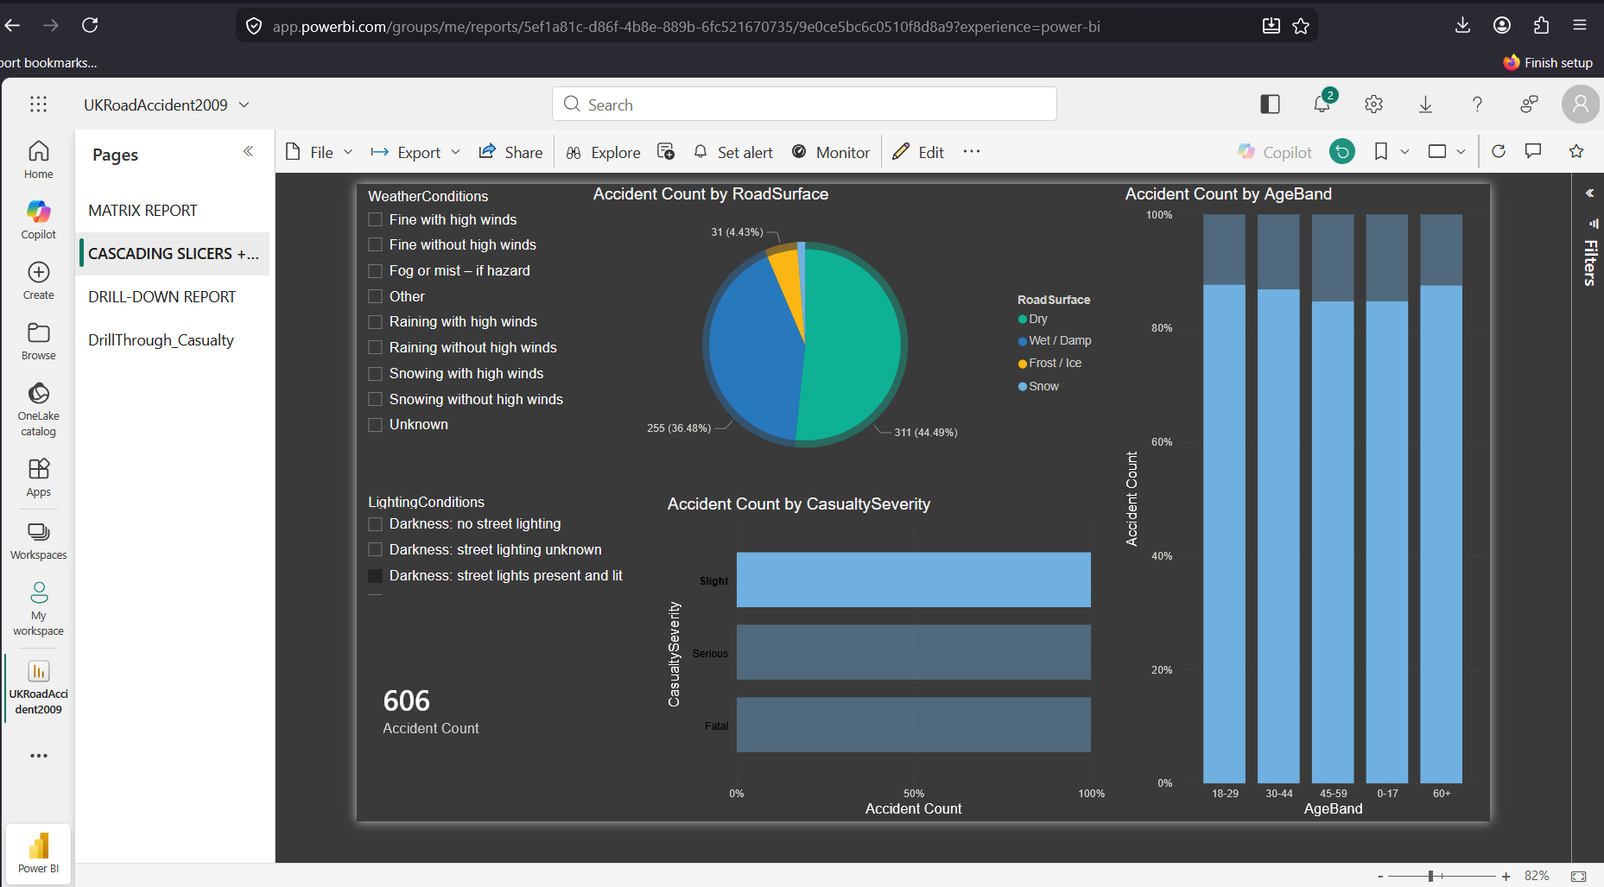

Figure 19: Power BI Reports Published in Power BI Service
This figure shows the reports published in Power BI Service, confirming successful deployment.

Summary
In this step, multiple Power BI reports were developed using the data warehouse as the source. The reports include matrix visualization, cascading slicers, drill-down analysis, and drill-through functionality.
These reports demonstrate the ability to transform raw data into meaningful insights and provide interactive analysis capabilities. The use of DAX measures and proper data modeling ensures accurate and efficient reporting.

